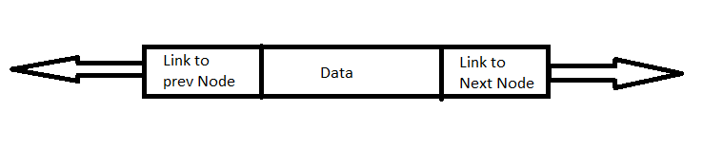

Node of Linked list



Node of Doubly linked list

1. **True:**

**Explanation:** Doubly linked list node structure contains two link. First one is for previous node and other one is for next node. So doubly linked list contains a single link to the next node.

1. **True:**

**Explanation:** Linked list or single linked list contains only single link and this single link point to the next node. Hence there is no way to travers back in linked list. But doubly linked list node structure havetwo link (link to previous node and link to next node) so in doubly linked list can travers backwards.

1. **False:**

**Explanation:** Doubly linked list have two pointers, one is for head node and other one is for tail node. But they can initialize to NULL pointers for empty doubly linked list.